**SDLC Methodologies**

WaterfallModel:

The Waterfall Model was first Process Model to be introduced. It is also referred to as a **linear-sequential life cycle model**.  It is very simple to understand and use.  In a waterfall model, each phase must be completed fully before the next phase can begin.   At the end of each phase, a review takes place to determine if the project is on the right path and whether or not to continue or discard the project. In waterfall model phases do not overlap.

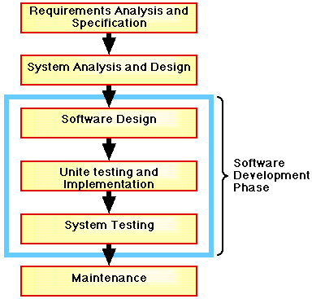

Spiral Model:

The Spiral Life Cycle Model is a type of iterative software development model which is generally implemented in high risk projects. It was first proposed by Boehm. In this system we combine the features of both, waterfall model and prototype model. In Spiral model we can arrange all the activities in the form of a spiral.  As originally envisioned, the iterations were typically 6 months to 2 years long.

Each phase starts with a design goal and ends with the client (who may be internal) reviewing the progress thus far. Analysis and engineering efforts are applied at each phase of the project.

Prototype is a working model of software with some limited functionality.

